

Software Requirements Specification

DeepCells - Cancer Prediction System

Version 1.0

06/06/2022

Malaysia-Japan Int’l Institute of Technology

Department of Software Engineering

Prepared by: Ruhul Quddus Tamim

Revision Page
- Overview
The current version of the document describes the introduction and specific requirements of the system. The scope, definition, reference, purpose, acronyms, abbreviation and overview of the system are included in the introduction. External interface requirements, system features (including use case diagram, domain model, state machine diagram, activity diagram, sequence diagram and use case specification), performance requirements, design constraints, software system attributes and other requirements of the system are included in specific requirements.
- Target Audience
Doctors and Patients.

- Project Team Members
List the team members and respective assigned module.

- Version Control History
Version | Primary Author(s) | Description of Version | Date Completed
Version 1.0 | Ruhul Quddus Tamim | Combined SRS, SDD, STD as SD

Note:
This Software Requirements Specification (SRS) template is based on IEEE Std 830-1998, organized by modules according to system features (Appendix A.5 of the IEEE Std, 830-1998, Section 5) and customized to meet the need of SCSJ2203 course at Faculty of Computing, UTM. Compiled and checked by Shahida Sulaiman, PhD on 20 March 2016. Examples of models are from Satzinger (2011).

Table of Contents
1.0 Introduction 1
1.1 Purpose 1
1.2 Problem Statement and Proposed Solution 1
1.3 Objectives 2
1.4 Project Aim 2
1.5 Scope 2
1.6 Definitions, Acronyms and Abbreviation 3
1.7 References 3
1.8 Overview 4
2.0 Overall Description 4
2.1 Product Perspective 5
2.1.1 System Interfaces 5
2.1.2 User Interfaces 5
2.1.3 Hardware Interfaces 6
2.1.4 Software Interfaces 6
2.1.5 Communication Interfaces 7
2.1.6 Memory 7
2.1.7 Operations 8
2.1.8 Site Adaptation Requirements 8
2.2 Product Functions 8
2.3 User Characteristics 10
2.4 Constraints 10
2.5 Assumption and Dependencies 11
2.6 Apportioning of Requirements 11
3.0 Specific Requirements 12
3.1 External Interface Requirements 14
3.1.1 User Interfaces 14
3.1.2 Hardware Interfaces 15
3.1.3 Software Interfaces 15
3.1.4 Communication Interfaces 15
3.2 System Features 16
3.2.1 Module <Registration Module> 16
3.2.1.1 UC001: Use Case <Registration> 16
3.2.2 Module <Admin module> 18
3.2.1.1 UC002: Use Case <Login> 19
3.2.1.2 UC003: Use Case <Add Doctor> 21
3.2.1.3 UC004: Use Case <View Doctor> 23
3.2.1.4 UC005: Use Case <Add Training Data> 25
3.2.1.5 UC006: Use Case <View Training Data> 27
3.2.1.6 UC007: Use Case <View User Details> 29
3.2.1.7 UC008: Use Case <Feedback> 31
3.2.3 Module <User module> 33
3.2.3.1 UC009: Use Case <Check results> 33
3.3 Performance Requirements 35
3.4 Design Constraints 35
3.5 Software System Attributes 35
3.6 Other Requirements 36
4.0 Appendices 37

1.0 Introduction

1.1 Purpose
This SD describes the Cancer Prediction System which is to make a new version of the current system that cannot work, for example like, some hospitals use decision support systems, but they are largely limited. They can answer simple queries like “What is the average age of patients who have cancer disease?”, “How many surgeries had resulted in hospital stays longer than 10 days?”, “Identify the female patients who are single, above 30 years old, and who have been treated for cancer.” However, they cannot answer complex queries like “Identify the important Preoperative predictors that increase the length of hospital stay”, “Given patient records on cancer, should treatment include chemotherapy alone, radiation alone, or both chemotherapy and radiation?”, and “Given patient records, predict the probability of patients getting a cancer disease”.

SD is the description, specification, development and deployment of a new software application. They may involve the internal production of specialized applications, the construction of database systems or the purchase of software developed by third parties.

1.2 Problem Statement and Proposed Solution
In 2022, cancer claimed the lives of 9.6 million individuals around the world, as per the data provided by WHO(World Health Organization). In addition, 0.3 million new cancer cases are detected each year in children aged 0 to 19. Cancer is one of the deadliest diseases that a person can contract. On the plus side, if cancer is identified at an early stage, roughly half (50%) of cancer can be prevented and treated. Otherwise, it may lead to a very critical situation and may even cause death. Lung cancer is among the most common genetic diseases that thousands of people die from each year. It develops in human body due to damage of normal genes caused by many reasons such as smoking cigarette, which chemically activate the oncogenes and deactivate the tumor suppressor the normal lung cell and produce mutations that result in tumors. This create a critical need for robust, fast, sensitive diagnostic tests. Therefore, it has become very important to develop a necessary system or technology that can help doctors detect cancer at an early stage where it can be treated effectively.

To solve this problem using artificial intelligence, an intelligent system is very much needed. The proposed system here is the Cancer Prediction System using the Naive Bayes Machine Learning algorithm. This system takes a statistical approach by employing probabilistic & optimization techniques to draw out a result based on past data-sets. This evaluation technique aims at helping doctors & pathologists to detect cancer at an early stage where it can be prevented & cured, thereby saving many lives.

1.3 Objectives
I. To collect the data-sets for types of cancer provided by organizations, e.g. UNICEF, World Health Organization(WHO).

II. To pre-process the data using data cleaning tools and prepare the data for training data-set.

III. To predict/test the data on the trained result and classify the data using Naive Bayes Machine Learning algorithm and display the class label.

1.4 Project Aim
The aim of this project is to classify the different types of cancer data as accurately as possible by almost (98 – 99)% in order to predict the symptoms for cancer types.

1.5 Scope
The software product is DeepCells – Cancer Detection System. Generally,
this system will allow the users to input necessary details and see the type
of cancer predicted at an early stage.

What the system can do:

- Allows the admin to login and view or add training data for the algorithm to analyze and predict results.

- Allows the admin to add or view specialist details with respect to types of cancer.

- Allows the admin to view all the registered users’ details and their feedback.

- Allows the user to register with their basic details and predict cancer by inputting all the necessary details and the system will accordingly view doctor to consult.

- Allow the user to view various doctor based on the predicted cancer.

What the system cannot do:

- The system cannot let the patient view the training data.

- The system cannot let the patient view other patient’s profile.

The objective and goals of this system are to upgrade the current problem scenario in the system and design the system which meets the administrative, organizational, and management requirements of hospital. In addition, CPS also allows the users to access the system anytime, anywhere with the internet connection

1.6 Definitions, Acronyms and Abbreviation
Definitions of all terms, acronyms and abbreviation used are defined as follow:
SD - System Development
CPS – Cancer Prediction System

1.7 References
N/A

1.8 Overview
The flow of the ERS operations are determined and represented by an as-is swimlane diagram. After clarifying with the current problem and processes, the to-be system is proposed in a separate swimlane diagram.

2.0 Overall Description
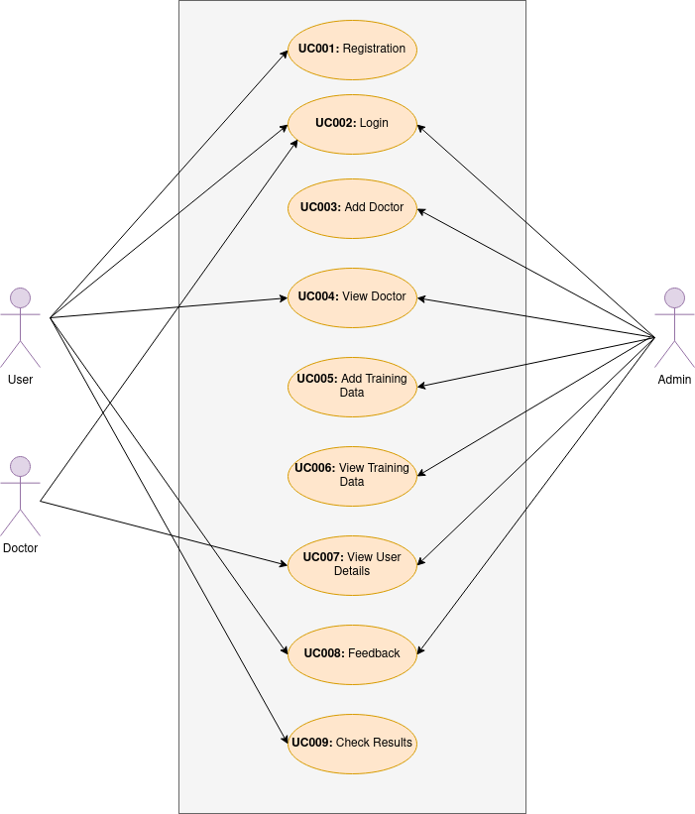
The system features include user registration, log-in, check results, view doctor, view/provide feedback, add training data, view user details, view training data, provide feedback.

Figure 2.1: Use Case Diagram of <Cancer Prediction System>

2.1 Product Perspective
The software described in this System Requirement Specification is the software documentation for the complete Cancer Prediction System. The system merges various hardware and software elements and further interfaces with external database. Thus, while the software covers the majority of the system's functionality, it relies on a number of external interfaces for persistence and unhandled tasks, as well as physically interfacing with humans.

2.1.1 System Interfaces
The Cancer Prediction System is an independent system which includes the system interface of the checking the type of cancer system. This will input the data and classify the data from database using data mining technique. The system should be able to return information to the Cancer Prediction System as to whether the classification has been made successfully classified or no.

2.1.2 User Interfaces
When a user uses the cancer prediction system for the first time, he or she needs to register an account by inserting few details. After registration, the user can login to the system successfully. When the user successfully login the system, the system shall display a main page that provides services that are relevant to the identity of the user. If the user is a patient, he or she will get to see functions such as view all doctors, check results, and provide feedback of using system. If the user is an admin, he or she will see functions like add training data, view user details, view feedback and view doctor details.

For the “view results” function, the user will brought to another page which will display the form asking to fill up the form and click on the submit button to check the results. After showing the results, it will display the user to view all the relevant doctors and also ask the user to provide feedback based on the usage of the system.

For the “Add training data” function, admin can add or delete data. After adding the data, admin can view all the data. Admin can also view all the user details.

2.1.3 Hardware Interfaces
The CPS system is required to communicate with the server as the system is a web-based system. With the existence of a server, it can store, receive and send files and data to computers through a network. For this project, localhost server(phpMyAdmin) is used.

Name: HPE Apollo 20 System

Processor Family: Intel Xeon Platinum 9200 Processor family

Memory: DDR4-2933 Registered Memory

Network: 1 GB integrated with PCI-e options available (per node)

Expansion slots: supports 4 PCIe x 16 slots (per node)

Storage: M.2 and U.2 storage options

2.1.4 Software Interfaces
1. The CPS system shall require any web browser including Google Chrome, Mozilla Firefox and Microsoft Edge to operate.

Name: Google Chrome
Version: 80.0.3987.149
Source: https://www.google.com/chrome/

Name: Mozilla Firefox
Version: 73.0.1
Source: https://www.mozilla.org/en-US/firefox/new/

Name: Microsoft Edge
Version: 80.0.361.62
Source: https://www.microsoft.com/en-us/edge

2. The server needs to be taken control by using proper server operating system such as Windows Server.

Name: Windows Server
Version: 10.0.17763
Source: https://www.microsoft.com/en-us/cloud-platform/windows-server

3. In order to manage all the data from e-rubric system, Database management system (DBMS) is very much needed.

Name: MySQL Database
Version: 5.6
Source: https://www.mysql.com/

2.1.5 Communication Interfaces
The CPS system shall always communicate with the server through several internet protocols such as Hypertext Transfer Protocol (HTTP), Domain Name System (DNS) and File Transfer Protocol (FTP).

2.1.6 Memory
The memory usage of the CPS System will obviously have to be constrained by the devices it is intended to run on. In particular, mobile devices, may have limited memory – this should be taken into account when writing the mobile software. Memory constraints upon the server surface computers and displays are not likely to be an issue as each will likely have at least a gigabyte of primary memory and hundreds of gigabytes or more of secondary memory.

2.1.7 Operations
The CPS System has only one mode of operation which is user-initiated operation. The system shall operate and run upon the command of the user. The server must be able to operate unattended indefinitely. It should not need physical interaction except for upgrades and failure of hardware elements. Backup and recovery should be handled within the database and operating system, or external software running on a timed backup system. Interaction from CPS System should not be required. Since stateful data should not be stored on any of the devices other than the server, keeping a system image on the server for each device may be a sufficient operational method to facilitate restoration should a device become corrupted.

2.1.8 Site Adaptation Requirements
Site configuration for the CPS System is expected to encompass the following steps:
• Install the server, surface computers and displays.
• Network all devices, install operating systems, server software and access to the database.
• Secure network, distribute initial passkeys.
• Preferable network connection for internet.
• Configure server RMOS software.

2.2 Product Functions
The main purpose of CPS System is to check the type of cancer. The functions of the system will be explained in terms of use case and modules as below:

I) Registration module
The registration module consists of registration for the patients. The interface would display the registration form and allow the user to register accordingly. Once the registration has been done successfully, they would need to login to proceed.

II) Admin module
Admin can add, modify or delete the training data. After adding the training data, other admins can view the data. Admin can access:
- Add Training Data and view training data
- Add Doctor Details
- View User Details
- View Feedback
- View Doctor Details

III) User module
User can check the results of their cancer types. The following are the steps:
- Register (With Details like Age, Gender, etc.)
- Check Cancer Symptoms by providing Details like

  - Age in Year
  - Gender
  - Blood or blood clots in the urine
  - Urination visit in a Day
  - Chest pain
  - Coughing up blood
  - Pain/Itching in the mouth
  - How many Red/white patch on the gums
  - Memory problems
  - How many reddish, raised patch on Skin?
  - Digestion or Cancer-burn
  - Pain, near the right shoulder blade, or in the back
  - How much Unexplained weight loss.

- System will accordingly view Doctor to consult.
- Give Feedback: User will provide feedback regarding the system.
- View Doctor: User can view various doctor based on the predicted cancer.

2.3 User Characteristics
The end user of this system falls into three main categories, basic skilled, partly skilled and highly skilled.

• Basic skilled
The applicants and agents who’ll be using the system to fill in the information and later to use the web applications and should therefore be assumed to have no relevant prior skills or education other than basic abilities to fill in the information in the system.

• Partly skilled user
The staff should be able to use the system and further be able to train others. They must be able to explain all elements of the user interfaces except the server. This class of user would be expected to have a junior high-school certificate education or equivalent.

• Highly skilled
The initial launching and configuration of hardware and the constituent CPS System components (especially the server) are guaranteed to require someone with notable computer experience with network and operation systems to complete it, the system should not be needlessly complex, but is still expected not to be entirely “plug and play”. This class of user

2.4 Constraints
Cancer Prediction System should be developed in an object-oriented language with strong GUI links and accessible network API. The primary candidate tool chains are JavaScript, HTML, CSS, SQL Management Studio and Asp.Net core. The System must provide a capacity for parallel operation and system design should not introduce scalability issues with regard to the number of surface computers or smartphones. There must be a strong audit chain with all system actions logged. The system must be reliable enough to run crash and glitch free more or less indefinitely or facilitate error recovery strong enough such that any failures are never revealed to its end-user. Finally, all the information and personal documents must be guaranteed that it won’t be used for any other purpose outside the university and registration limits as well as it won’t be accessible for people.

2.5 Assumption and Dependencies
The SRS assumes that none of the constituent system components will be implemented as embedded applications. The implication is that the target hardware will provide a capacity for standalone program/application deployment and not require customized embedded firmware to be written. It is further assumed that PCs, laptop, smartphones of sufficient processing capability will be utilized. The computers employed by the system should facilitate being utilized on for extended periods and that they are programmable in the same fashion as x86 architecture computers. Finally, it is further assumed that the deployment environment is capable of supporting an IEEE 802.11 wireless network for system communication. The DBMS will be used properly in order to store the data and guarantee of no data loss. The system will depend on the any third parties platform. So, there will not be any dependencies for the Cancer Prediction System.

2.6 Apportioning of Requirements
N/A

3.0 Specific Requirements

A domain model is a conceptual model of the domain that incorporates both behavior and data.
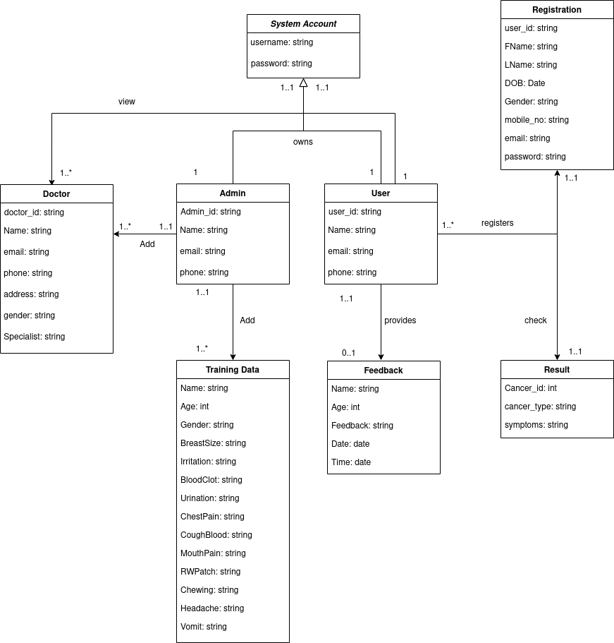
Figure 3.1: Domain Model of <Cancer Prediction System>
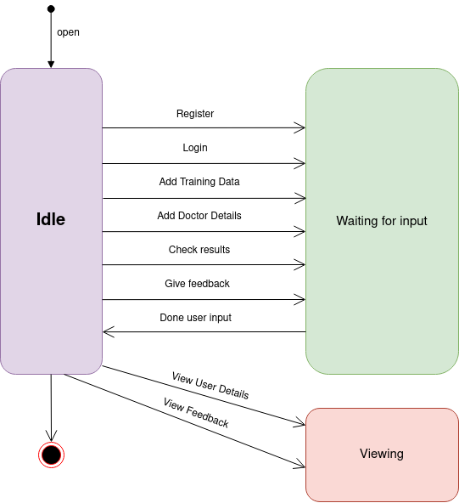
Figure 3.2: State Machine Diagram of the Cancer Prediction System

3.1 External Interface Requirements

3.1.1 User Interfaces
There are two user interfaces used by the Cancer Prediction System, each related to an interfaced hardware device. These user interfaces are the Surface Computer UI and the Mobile UI.

Surface computer UI
The Surface Computer UI is the interface used by users and administrators. This interface uses the surface computer paradigm - users interact with the system by clicking on options and filling up forms using button and text box available. For the Cancer Prediction System, users can type in information, allow it to be saved in the database and admin upload newly training documents accordingly.

Mobile UI
The Mobile UI is not specifically designed for this system. But at-least, a mobile view based is done so that the user can at-least use the web application from mobile devices.

3.1.2 Hardware Interfaces
• Database servers
Use the available database that’s connected to the users’ devices (computers -wireless mobile phone).

• Computers and wireless mobile phone.
It should be able to adapt to the basic functions that will guarantee a smooth performance and a successful completion for all the tasks that it’s expected to be done in the system. For instance, having an internet connection and the ability to connect to all the servers and retrieve the required data such as the textual one. Any device can’t be connected to the internet due to any reasons can’t use access the system and perform any function.

3.1.3 Software Interfaces
• Cancer Prediction Database.
This connection will provide all the required data from and to the system and Cancer Prediction Database such as the users’ personal information, doctor’s details and for admin such as adding of training data, view users’ details and view feedback.

3.1.4 Communication Interfaces
• Connection type.
Having Ethernet as well as LAN cards to keep the connection between the server and the devices using the system.
• IEEE 802.11b/g standard for the devices using Ethernet cards so it will have support for:
• WPA2-PSK encryption.

3.2 System Features

3.2.1 Module <Registration Module>
This module will provide the functions for the user registration. This module contains one use case. By using this module, the users can register into the CPS system by providing all the necessary details.

3.2.1.1 UC001: Use Case <Registration>
Table 3.1: Use Case Description for <Registration>
Use Case name | Registration
Use case ID | UC001
Actors | Patient
Pre-conditions | 1. Potential user has access to Cancer Prediction System.  2. User isn’t already registered with the same e-mail address.
Normal flow | - Potential user shall open the CPS System by using any  browser.  - Potential user shall create an account in CPS system by filling necessary information’s.  - Once form is filled, input is sent for verification.  - If input verification is failed, exception flow 1 is performed.  - If input verification is success, register account is successful.  - User shall be able to log in to proceed with their credentials.
Post Conditions | Successful Completion  1. The potential applicant (User) register account is successful.
Alternative Flow
Exception flow | 1. Input verification is failed.  1.1: Request to check again on information used for registration.

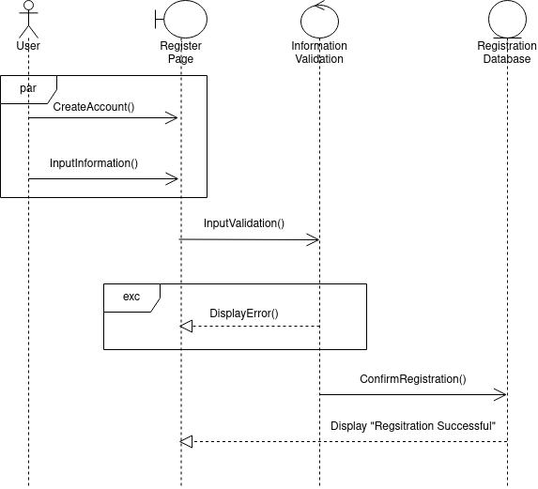
Patient
Figure 3.3: System Sequence Diagram of <Registration>
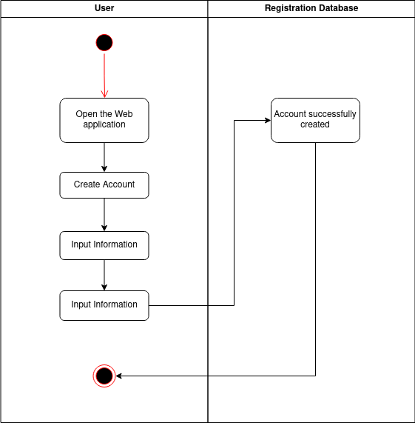
Figure 3.4: Activity Diagram of <Registration>

3.2.2 Module <Admin module>
This module will provide the several functions for the admin. This module contains six use cases. By using this module, the admin can login, add training data, add doctor details, view doctor details, view user details and view the feedback.

3.2.1.1 UC002: Use Case <Login>
Table 3.2: Use Case Description for <Login>
Use Case name | Login
Use case ID | UC001
Actors | User, Admin, Doctor
Pre-conditions | Potential actor has access to the Cancer Prediction System
Normal flow | - User type in username and password based on their role / type of account.  - User then clicks “Login” button.  - If information is valid, user can view their dashboard depending on the type of account. If username and password is entered wrong, Exception E1 is performed.  If the account doesn’t exists in the system, Exception E2 is performed.
Post Conditions | Account successfully validated and the actors are able to view dashboard.
Exception flow | E1. Invalid password or username is entered  If in step 2 in the normal flow, the user submits the wrong password or username, then -  1. The system will display a message to indicate the user that either the password or username is wrongly entered.  2. The user will need to return to step 2 again to enter the proper username and also the password in step 3 in normal flow.  E2. Username does not exist in the system  If in step 4 in the normal flow, the user submits the username or password that does not exist in the system, then  1. The system will display a message to indicate the user that he or she has no account.
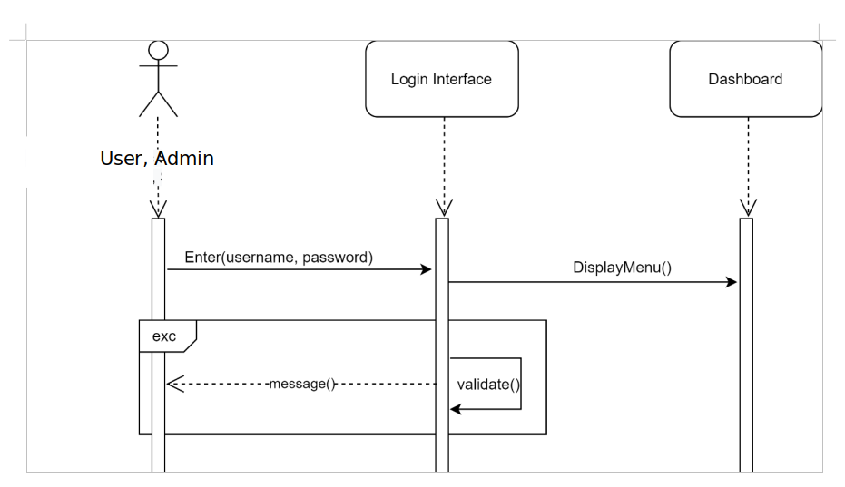

Patient, Admin, Doctor

Figure 3.5: System Sequence Diagram of <Login>

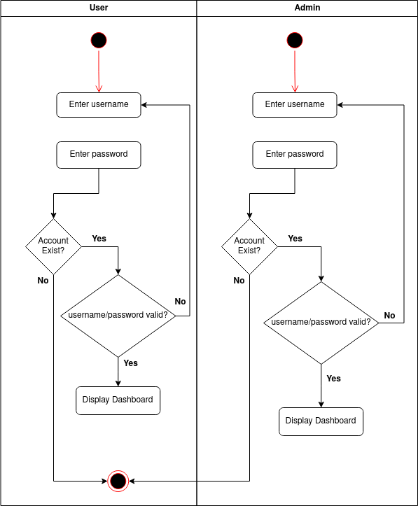
, Doctor

Figure 3.6: Activity Diagram of <Login>

3.2.1.2 UC003: Use Case <Add Doctor>
Table 3.3: Use Case Description for <Add Doctor>
Use Case name | Add Doctor
Use case ID | UC003
Actors | Admin
Pre-conditions | Admin must be logged into the system
Normal flow | 1. Admin click on the “Add Doctor” page.  2. Admin types in the information to fill up the form.  3. If the information is valid, the details of the doctor will be added into the database.
Post Conditions | Successfully added doctor details
Alternative Flow
Exception flow | 1. Input verification is failed.  1.1: Request to check again on information used for doctor details.
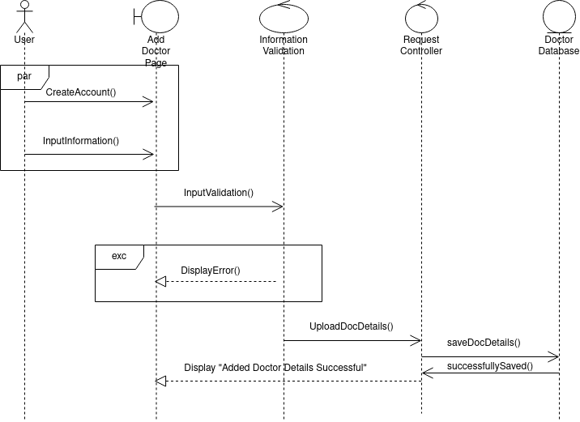
Admin
Figure 3.7: System Sequence Diagram of <Add Doctor>

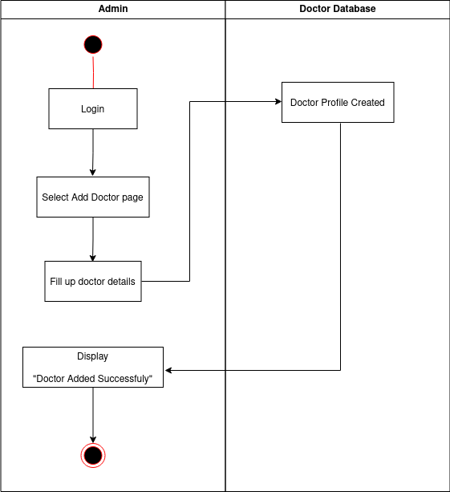

Figure 3.8: Activity Diagram of <Add Doctor>

3.2.1.3 UC004: Use Case <View Doctor>
Table 3.4: Use Case Description for <View Doctor>
Use Case name | View Doctor
Use Case ID | UC004
Actors | Patient, Admin
Pre-conditions | Admin or User must be logged into the system
Normal flow | 1. Admin or User click on the “View Doctor” page.  2. The system will display the user or admin a list of doctors’ profiles.  3. If the actors chooses to back, Alternative is followed.
Post Conditions | Displays a list of doctors
Alternative Flow | Back to Main Menu  1. The system redirects users to the Main Menu page.  2. The user can select other functions.
Exception flow

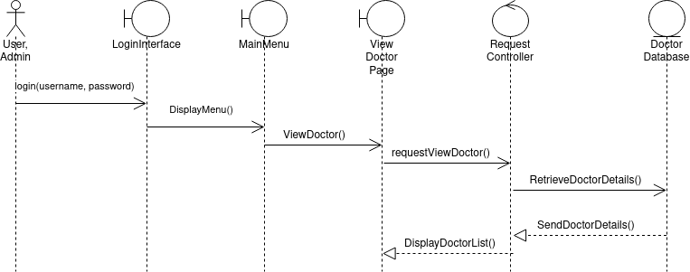
Patient, Admin
Figure 3.9: System Sequence Diagram of <View Doctor>

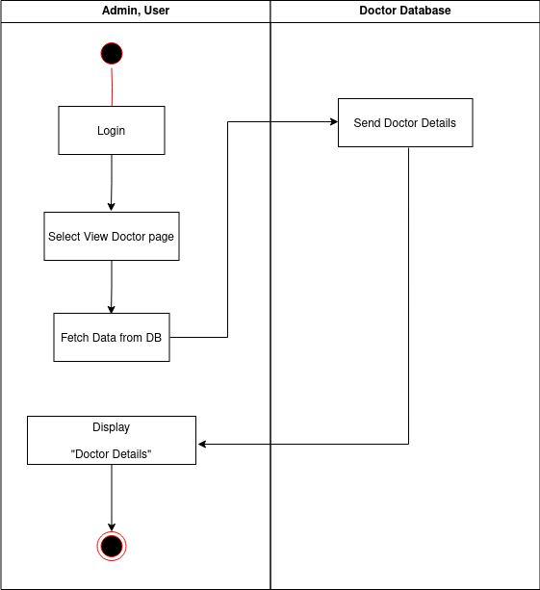

Figure 4.0: Activity Diagram of <View Doctor>

3.2.1.4 UC005: Use Case <Add Training Data>
Table 3.5: Use Case Description for <Add Training Data>
Use Case name | Add Training Data
Use Case ID | UC005
Actors | Admin
Pre-conditions | Admin or User must be logged into the system
Normal flow | 1. Admin or User click on the “Add Training Data” page.  2. The system will display the admin to upload data.  3. Admin will click on the upload button to upload excel data into the system.  4. The use case ends.
Post Conditions | Data successfully added
Alternative Flow
Exception flow
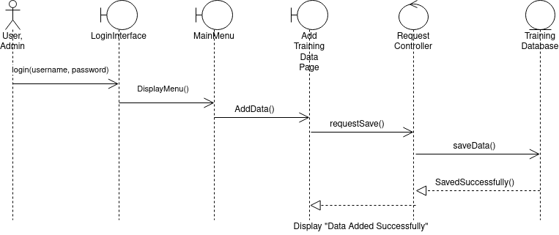
Admin
Figure 4.1: System Sequence Diagram of <Add Training Data>

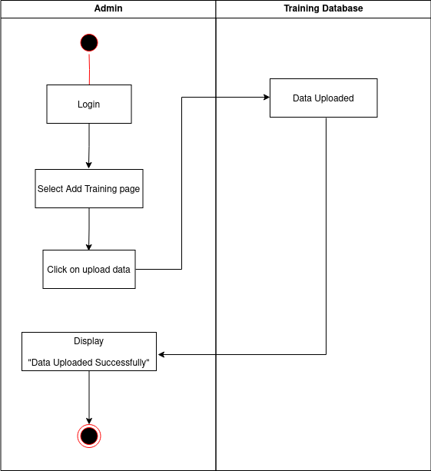
Figure 4.2: Activity Diagram of <Add Training Data>

3.2.1.5 UC006: Use Case <View Training Data>
Table 3.6: Use Case Description for <View Training Data>
Use Case name | View Training Data
Use Case ID | UC006
Actors | Admin
Pre-conditions | Admin must be logged into the system
Normal flow | 1. Admin or User click on the “View Training Data” page.  2. The system will display all the training data.  3. The use case ends.
Post Conditions | Training data will be displayed successfully
Alternative Flow
Exception flow

Admin
Figure 4.3: System Sequence Diagram of <View Training Data>

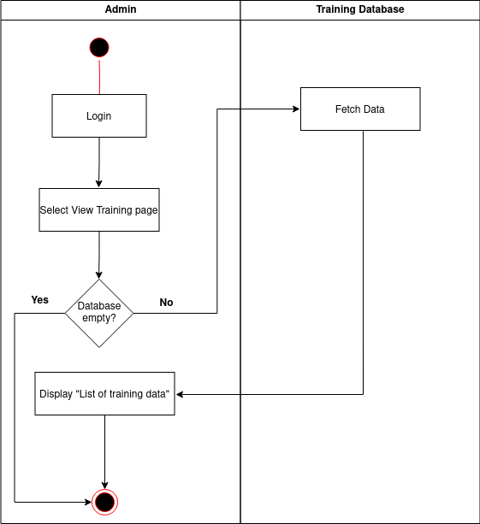

Figure 4.4: Activity Diagram of <View Training Data>

3.2.1.6 UC007: Use Case <View User Details>
Table 3.7: Use Case Description for <View User Details>
Use Case name | View User Details
Use Case ID | UC007
Actors | Admin, Doctor
Pre-conditions | Admin must be logged into the system
Normal flow | 1. Admin or doctor click on the “View User Details” page.  2. The system will display all the user profiles.  3. The use case ends.
Post Conditions | All the user profile will be displayed successfully
Alternative Flow
Exception flow

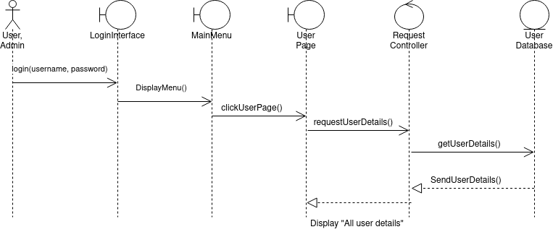
Admin, Doctor
Figure 4.5: System Sequence Diagram of <View User Details>

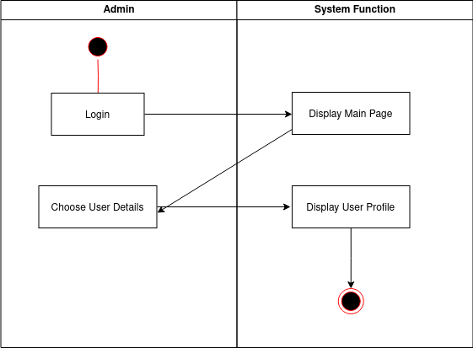
, Doctor
Figure 4.6: Activity Diagram of <View User Details>

3.2.1.7 UC008: Use Case <Feedback>
Table 3.8: Use Case Description for <Feedback>
Use Case name | Feedback
Use Case ID | UC008
Actors | Admin, Patient
Pre-conditions | Admin or User must be logged into the system
Normal flow | 1. Admin or User click on the “Feedback” page.  2. If the actor is user, the system will ask to write feedback and submit.  3. If the actor is admin, the system will display all the feedback submitted by the user.  3. The use case ends.
Post Conditions | 1. If user, the system will display “Feedback submitted successfully”  2. If admin, the system will display a list of feedback with users’ name.
Alternative Flow
Exception flow
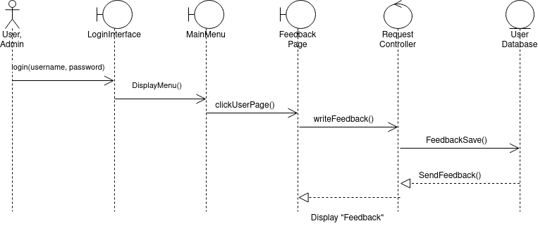
Patient, Admin
Figure 4.7: System Sequence Diagram of <Feedback>

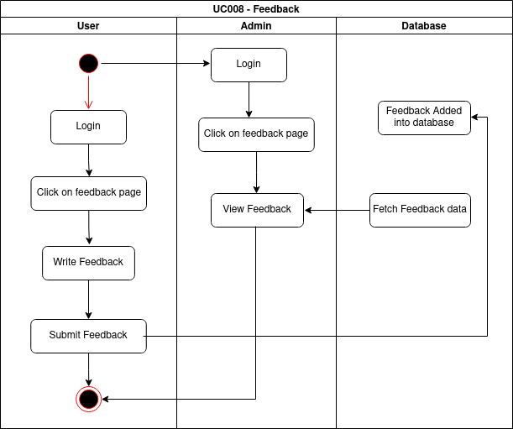

Figure 4.8: Activity Diagram of <Feedback>

3.2.3 Module <User module>

3.2.3.1 UC009: Use Case <Check results>

Table 3.8: Use Case Description for <Check Results>
Use Case name | Feedback
Use Case ID | UC008
Actors | Patient
Pre-conditions | User must be logged into the system
Normal flow | 1. User click on the “Check Result” page.  2. User will type in all the details in the form.  3. After filling up the form, user will click on the “check” button  4. The system will classify the user’s data against the database and display the type of cancer with symptoms.  3. The use case ends.
Post Conditions | Display the type of cancer detected with its symptoms
Alternative Flow
Exception flow

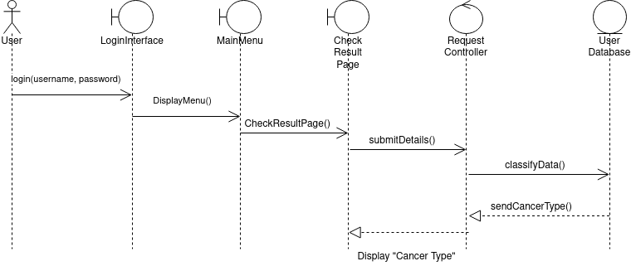
Patient
Figure 4.9: System Sequence Diagram of <Check Result>

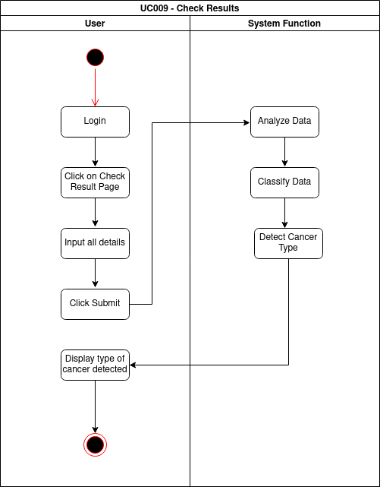

Figure 5.0: Activity Diagram of <Check Result>

3.3 Performance Requirements
1. The Cancer Prediction system server shall be capable of supporting an arbitrary number of active users, that is, no application shall be lost under any circumstances.
2. The system response time must be at most 8.5 to less than 5 second.
3. The database should be able to store limitless data and files of users and admins.
4. The system shall not disclose the user information’s to any third party under any circumstances.

3.4 Design Constraints
1. For non-functional requirements the system shall be able to authorize users via username and password.
2. The user manual should be structured clearly and simple with example. The manual should explain to the user what the software should do and how it functions. The manual is used as a reference so that the user can understand the system easily.
3. Users should be able to access the system from any device that has internet
connection and internet browsing.
4. The information of the users are only able to be accessed by authority that is authorized by the system.
5. The system shall support up to 1000 users at the same time with loading time is at most 8.5 to less than 5 seconds.

3.5 Software System Attributes
1. The system must be able to make users recognize the symbol and icon used in the system, hence the system must be easy to use by having a simple but attractive interface so that the user will be able to know what to do.

2. The system must provide users with valid id and password with no duplication so that users can access the system.

3. The information must be protected from unauthorized users to block from accessing the system.
4. The language used in the system should be English or Malay so it can be understood by all users based on the user chooses the language.

5. The system code should be written clearly and easy for other developer to understand and be able to modify the system with new requirements when needed.

3.6 Other Requirements
This section shows the list of quality characteristics in the design and implementation of the system related to non-functional requirements.

1) Adaptability
The system will be in English or Malay based on the user chooses which language to use so that all students are able to access the system easily.

2) Security
I. The system requires user id and password to log in to the system for both user and admin.
II. The system will automatically log out of the system after 10 minutes if no activity is
done.

3) Maintainability
I. The system should be able to back-up all the data.
II. The system should update the software regularly to increase security and stay updated with new software.
4) Portability
I. Users can use the system at any time as the system uses a web-based platform.
II. Any type of device that has a web browser and internet connection are able to use the system.

5) Reliability
I. The system can be used by multiple users at one time.
II. The system will run 24 hours a day everyday unless maintenance is required.

6) Re-usability
The system should implement an already existing design and reuse existing functions that are linked to the library code.

7) Usability
The system is easy to be used by the students and lecturer as the design and the layout is understandable and has good documentation of the interface.

4.0 Appendices

N/A

